AHEC Assembly Minutes

Date: Saturday, April 27th, 2024, 6:00pm

Introduction
- Introduce new AHEC members.

Purpose of the assembly
- Update the officers with what is going on in the Ashdown house.
- Chance to communicate ideas and policies.

State of the treasury
- Wentao
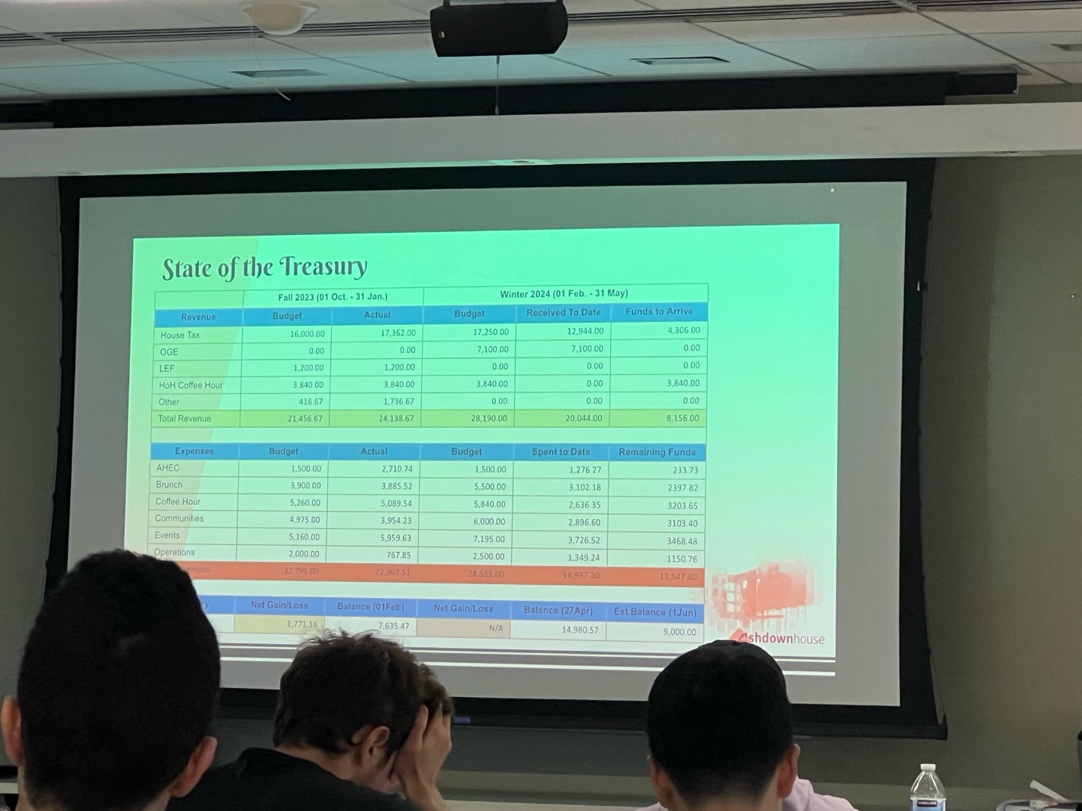

State of the officer body
- Yanina
- 6 committees + AHEC = 80 officers
- 17 new hires in Spring 2024
- Max 75 officer lease every Spring

State of the Internal Lottery
- Shakul
- Previous lottery: successfully conducted with 16/22 people getting a new assignment.
- Now incorporated seniority points.
- Might incur a moving fee in the future.

State of the Election Committee
- 2 candidates, a total of 87 votes

State of the Brunch Committee
- Around 200 serving sizes.
- Once every month.
- Officers’ responsibility is to help with the preparation of the food.

Coffee Hour Committee
- Serve food once a week.
- New project, serve coffee on Monday/Wednesday mornings.

Communities Committee
- Fostering a sense of community.
- Floor outings, game nights, cherry pie society, art events, and wellness event
- Organize community service around the Cambridge and Boston areas.

Events Committee
- Runs special events for Ashdown.
- Officers can pick the kinds of events they wish to run.

Tech and inventory committee
- Work behind the scenes to keep Ashdown moving
- Website upkeep, front desk inventory, common space inventory, garden, bike cleanout
- Working on the check-in and check-out system at the front desk

Publicity
- Record and disseminate information in Ashdown
- Manage 3 AM newsletter, Instagram, and Facebook, etc.

Poll
- Merch giveaway rule.
- Do officers get early access to food?
- How many hours per month is reasonable?
- Ashdown officer calendar to mark absence?
- Assembly format?
- Assembly frequency?

Open floor
- State of vacuums? Only one works and a few are hidden in people’s rooms. Two new vacuums will be tagged with air tags.

